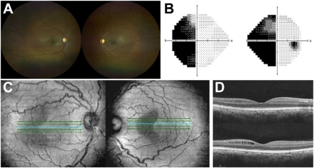

A 33-year-old woman presented for evaluation with a history of craniopharyngioma, status postresection in childhood. Fundoscopicexamination showed bilateral optic nerve pallor (A) and Humphrey Visual Field 24-2 revealed a left homonymous hemianopia (B). Spectraldomain en-face OCT imaging demonstrated hemi-macular hyporeflectivity respecting the vertical mid-line (C). Structural B-scan as Figure D. Based on the provided images and clinical description please make an ophthalmic diagnosis for this patient. And output the diagnostic conclusions only

**Retrograde Trans-synaptic Degeneration of the Retina**